SQL:
Q.1) Create collegedb
Q.2)In collegedb create table as Students with field(studid,name,course,marks) (course-IT,DATA SCIENCE,COMPUTER SCIENCE)

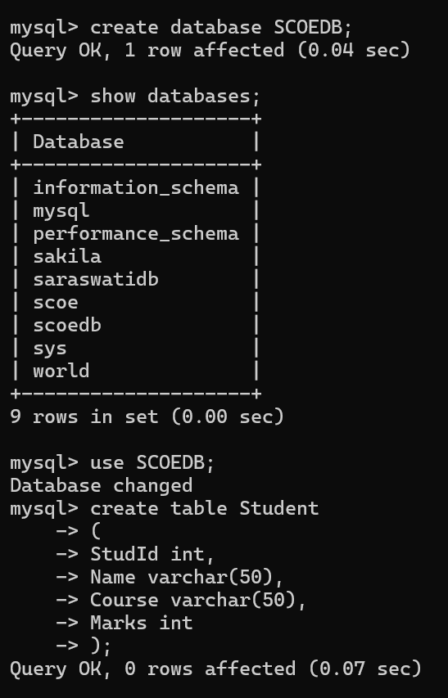

Q.3) View table structure

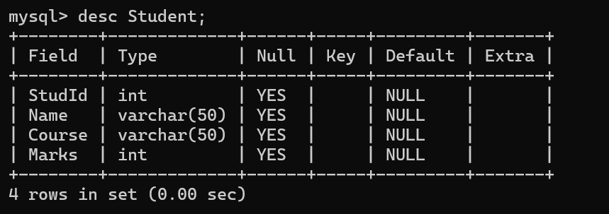
Q.4) Insert minimum 10 records.
Q.5) Retrieve all data
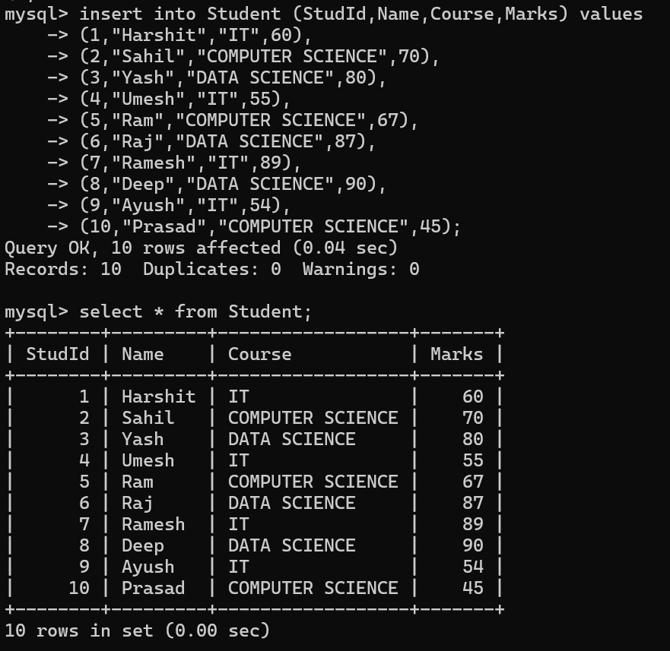

Q.6) select name and marks from Students table.
Q.7)Update student’s marks to 50 whose studid 4
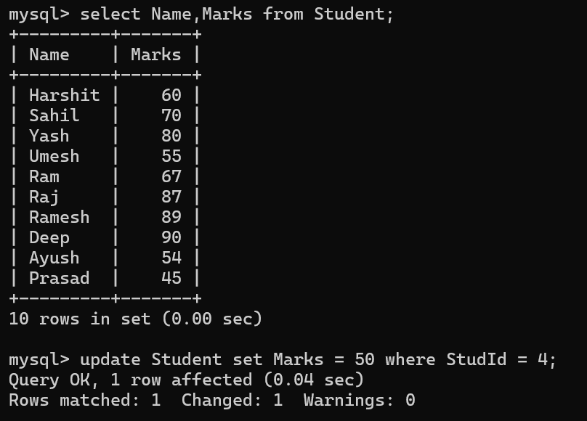

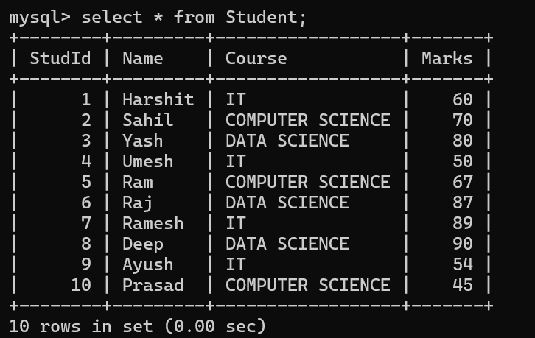

Q.8)Show all the students who scored more than 50 marks
Q.9) Delete record of studid 7.
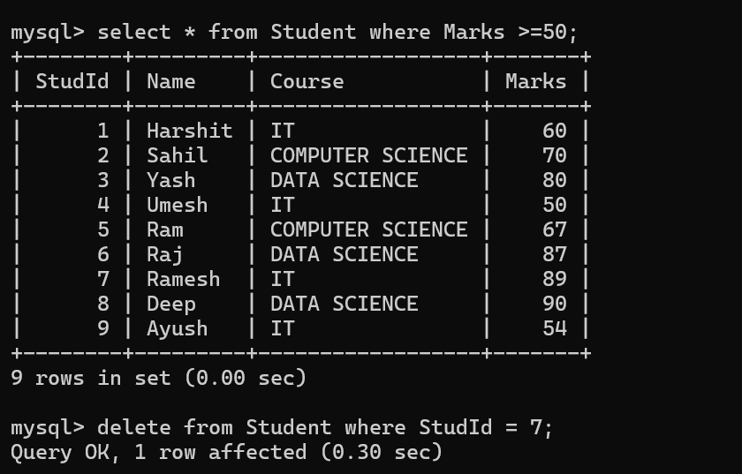

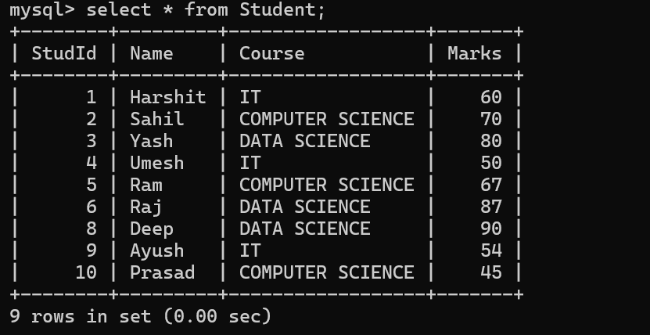
Q.10)Select student’s whose course is “IT”

